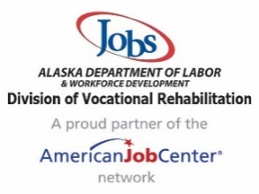
Division of Vocational Rehabilitation (DVR) Program Highlights State Fiscal Year 2025
Mission of DVR – To assist individuals with disabilities to obtain and maintain employment

Vocational Rehabilitation (VR) Highlights
- 1,997 individuals with disabilities received services
- 97% of individuals receiving services experienced significant disabilities with multiple barriers to employment
- 881 individuals applied for VR services
- 1,292 individuals received information and referral services
- $3,600,372 was spent on services to individuals in the VR program
- 288 individuals exited the VR program employed
  - $20.51 was the average hourly wage
  - 218 individuals were employed in the private sector
  - 56 individuals were employed in Federal, State, or Local Government
  - 14 individuals were self-employed
- 46 students with disabilities received services from the VR program
- $114,887 was spent on Pre-Employment Transition Services from the VR program

Potentially Eligible (PE) Students with a Disability Highlights
- 1,436 students with disabilities received services from the PE transition program
- A total of 1,482 students with disabilities received services from the PE and VR transition programs
- Students served under the PE program were from 116 Alaskan communities and 81% of those students live in rural Alaska
- $1,977,476 was spent on Pre-Employment Transition Services from the PE program

DVR Participants at a Glance
Race (Participants may choose more than one race)
- 60% Caucasian
- 24% Alaska Native
- 11% Black or African American
- 3% Asian
- 2% Hawaiian Native or Other Pacific Islander
Occupation Breakdown
- 34% Office and Administrative Support
- 12% Production/Construction/Operating, Maintenance and Material Handling
- 8% Sales and Related
- 7% Food Preparation and Serving Related
- 6% Arts, Design, Entertainment, Sports and Media
- 5% Personal Care and Service
- 28% All Other Occupations
Disability Types (% includes all disabilities per participant)
- 36% Psychosocial
- 33% Cognitive
- 19% Physical and Orthopedic
- 7% Blindness/Visual Impairment
- 4% Deafness/Hearing Loss
- 1% Communication Impairment

